SATURN 2017

A Hands on Introduction to Docker

Len Bass

HandsAHandsonon introductionIntroductiontotoDockerDocker
May 1–4, 2017 | 1
©2017 Len Bass | 1
©2017 Len Bass | 1

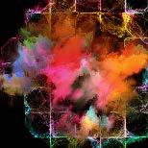
SATURN 2017

Setting expectations

This is an introduction to Docker intended for those who have no hands on experience with Docker.

If you have used Docker you will likely not get much from this session.

The material (and hands on portion) is taken from the course that I teach at CMU called DevOps: Engineering for Deployment and Operations.

SATURN 2017

Logistics

You should have installed Docker on your laptop – either in native mode or using Docker Toolbox.

Make sure Hello World works (from the installation instructions).

Make sure you have access to the internet since you will be downloading software.

A Hands on Introduction to Docker
May 1–4, 2017 3

©2017 Len Bass

SATURN 2017

Outline

Introduction to Docker

Hands on

What’s left?

A Hands on Introduction to Docker
May 1–4, 2017 4

©2017 Len Bass

SATURN 2017

Isolation

Process |  | Virtual Machine
• | Isolate address space | • | Isolate address space
• No isolation for files or |  | • | isolate files and
• | networks | • | networks
• | Lightweight | • | Heavyweight

A Hands on Introduction to Docker
May 1–4, 2017 5

©2017 Len Bass

SATURN 2017

Containers

Process

- Isolate address space
- No isolation for files or networks

- Lightweight

Container |  | Virtual Machine
• | Isolate address space | • | Isolate address space
• | isolate files and | • | isolate files and
• | networks |  | networks
• | Lightweight | • | Heavyweight
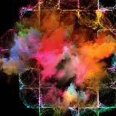

A Hands on Introduction to Docker
May 1–4, 2017 6

©2017 Len Bass

SATURN 2017

Docker containers
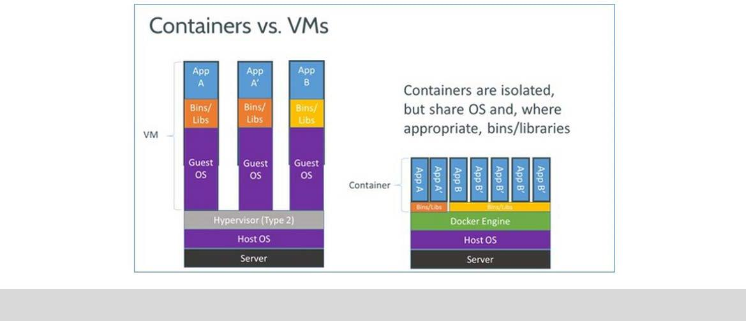

A Hands on Introduction to Docker
May 1–4, 2017 7

©2017 Len Bass

SATURN 2017

Docker Architecture
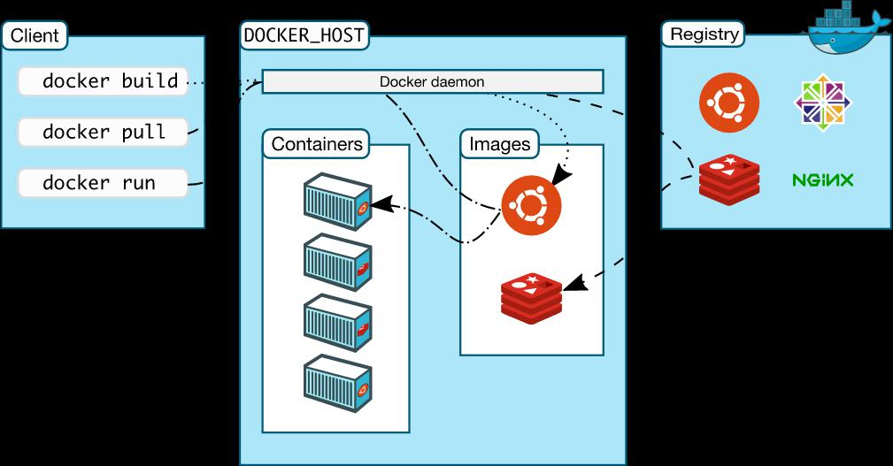

Docker daemon |  | Docker daemon
• | Lives on the | • Instantiates
• | host | images and
• | Responds to | creates
 | docker | containers
 | commands

Image is instantiated to form container

A Hands on Introduction to Docker
May 1–4, 2017 8

©2017 Len Bass

SATURN 2017

Layers

A Docker container image is structured in terms of “layers”.

Process for building image

- Start with base image

- Load software desired

- Commit base image+software to form new image

- New image can then be base for more software

Image is what is transferred

A Hands on Introduction to Docker
May 1–4, 2017 9

©2017 Len Bass

SATURN 2017

Loading of software

OS is ~ 1GB(yte)

Fast network is ~ 1Gb(it) rated

Since there are 8 bits per byte, transferring an OS should take 8 seconds.

But a 1Gb rated network is ~35Mb in practice This means loading an OS is >30 seconds

Consequently, sharing an OS saves >30 seconds per instance. Sharing other software saves more

*http://www.tomshardware.com/reviews/gigabit-etherne-bandwidth,2321-3.html

A Hands on Introduction to Docker
May 1–4, 2017 10

©2017 Len Bass

SATURN 2017

Exploiting layers

When an image is updated, only update new layers Unchanged layers do not need to be updated

Consequently, less software is transferred and an update is faster.

A Hands on Introduction to Docker
May 1–4, 2017 11

©2017 Len Bass

SATURN 2017

Trade offs

Virtual machine gives you all the freedom you have with bare metal

- Choice of operating system

- Total control over networking arrangement and file structures

Container is constrained in terms of operating systems available

- Currently just Linux but soon Windows and OSX

- Provides limited networking options

- Provides limited file structuring options

A Hands on Introduction to Docker
May 1–4, 2017 12

©2017 Len Bass

SATURN 2017

Outline

Introduction to Docker

Hands on

What’s left?

A Hands on Introduction to Docker
May 1–4, 2017 13

©2017 Len Bass

SATURN 2017

Hands on portion

If you have loaded Docker Toolbox, you have a copy of VirtualBox

Set port forwarding on “default” so that 8080 on host is forwarded to 8080 on VM.

A Hands on Introduction to Docker
May 1–4, 2017 14

©2017 Len Bass

SATURN 2017

docker pull ubuntu

Execute “docker pull Ubuntu”

This loads an image from the docker library

The image contains bare copy of ubuntu

A Hands on Introduction to Docker
May 1–4, 2017 15

©2017 Len Bass

SATURN 2017

docker images

Execute “docker images”

This generates a list of images known to Docker on your machine

You should see Hello World and ubuntu

A Hands on Introduction to Docker
May 1–4, 2017 16

©2017 Len Bass

SATURN 2017

docker run –i –t ubuntu

Execute docker run –i –t Ubuntu

This executes an image. An executing image is called a “container”.

You are now inside the container.

Execute “ls”.

- A directory structure is set up but only a bare bones OS has been loaded

A Hands on Introduction to Docker
May 1–4, 2017 17

©2017 Len Bass

SATURN 2017

Install software on container

Execute

apt-get update

apt-get install wget

apt-get install nodejs

apt-get install npm

<cntl d>

This installs the software you will use during this session and exits the container

A Hands on Introduction to Docker
May 1–4, 2017 18

©2017 Len Bass

SATURN 2017

docker ps –a

Execute “docker ps –a”

This generates a list of all of the containers that have been run

A Hands on Introduction to Docker
May 1–4, 2017 19

©2017 Len Bass

SATURN 2017

Output from docker ps -a

CONTAINER ID IMAGE COMMAND

CREATED STATUS PORTS

NAMES

174268c64fbd ubuntu "/bin/bash" 7 minutes

ago Exited (0) About a minute ago

sharp_mcnulty

54ae910238b3 hello-world "/hello" 53

minutes ago Exited (0) 53 minutes ago

practical_euler

A Hands on Introduction to Docker
May 1–4, 2017 20

©2017 Len Bass

SATURN 2017

docker commit sharp_mcnulty saturn

Note that the ubuntu container has a name of “sharp_mcnulty” (on my machine). It will be different on yours.

“docker commit sharp_mcnulty saturn” creates an image with the name saturn

A Hands on Introduction to Docker
May 1–4, 2017 21

©2017 Len Bass

SATURN 2017

Execute “docker images”

REPOSITORY TAG IMAGE ID

CREATED SIZE

saturn latest a70567971230 13 seconds

ago 456 MB

ubuntu latest 0ef2e08ed3fa 8 days ago

130 MB

hello-world latest 48b5124b2768 7 weeks

ago 1.84 k

A Hands on Introduction to Docker
May 1–4, 2017 22

©2017 Len Bass

SATURN 2017

Execute “run –i –t Saturn”

You are back inside a container. Load application:

wget

https://raw.githubusercontent.com/cmudevops/ipshow.js/mast

er/initialization_script

wget

https://raw.githubusercontent.com/cmudevops/ipshow.js/mast

er/ipshow.js

A Hands on Introduction to Docker
May 1–4, 2017 23

©2017 Len Bass

SATURN 2017

Exit the container - <cntl d>

A Hands on Introduction to Docker
May 1–4, 2017 24

©2017 Len Bass

SATURN 2017

List containers

$docker ps -a
CONTAINER ID | IMAGE |  | COMMAND | CREATED
STATUS | PORTS |  | NAMES
9c4b32145fa3 | saturn | "/bin/bash" |  | 2 minutes ago
Exited (0) 8 seconds ago |  |  | reverent_lewin
174268c64fbd | ubuntu |  | "/bin/bash" | 30 minutes ago
Exited (0) 24 minutes ago |  |  | sharp_mcnulty
54ae910238b3 | hello-world |  | "/hello" | About an hour
ago Exited (0) About an hour ago |  |  | practical_euler

A Hands on Introduction to Docker
May 1–4, 2017 25

©2017 Len Bass

SATURN 2017

Make an image called ipshow

docker commit reverent_lewin ipshow

$ docker images

REPOSITORY | TAG | IMAGE ID | CREATED
SIZE
ipshow | latest | 8f7afedea65d | 6 seconds ago | 456 MB
saturn | latest | a70567971230 | 11 minutes ago | 456
MB
<none> | <none> | b348af319cbc | 21 minutes ago 456
MB
ubuntu | latest | 0ef2e08ed3fa | 8 days ago | 130 MB
hello-world | latest | 48b5124b2768 | 7 weeks ago | 1.84 k

A Hands on Introduction to Docker
May 1–4, 2017 26

©2017 Len Bass

SATURN 2017

Execute app

docker run –i –t –p 0.0.0.0:8080:8080 ipshow /bin/bash /initialization_script

In browser: localhost:8080

You should see three ip addresses in the browser:

Ip address of local host

127.0.0.1 (conventially this is local host)

Ip address of container

A Hands on Introduction to Docker
May 1–4, 2017 27

©2017 Len Bass

SATURN 2017

What have we seen

Distinction between docker images and containers

Creating a docker image in layers

Provisioning the docker image from the internet

A Hands on Introduction to Docker
May 1–4, 2017 28

©2017 Len Bass

SATURN 2017

What is left?

Scripting

Sharing of images

Scaling of images

- Swarm

- AWS container service

- Lambda

A Hands on Introduction to Docker
May 1–4, 2017 29

©2017 Len Bass

SATURN 2017

Scripting

Creating an image by hand is tedious and error prone You can create a script to do this (Dockerfile).

A Hands on Introduction to Docker
May 1–4, 2017 30

©2017 Len Bass

SATURN 2017

Sharing image

Multiple team members may wish to share images

Images can be in production, under development or under test

Docker Hub is a repository where images can be stored and shared.

- Each image is tagged to allow versioning

- Any image can be “pulled” to any host (with appropriate credentials)

- Tagging as “latest” allows updates to be propagated. Pull <image name>:latest gets the last image checked into repository with that name.

A Hands on Introduction to Docker
May 1–4, 2017 31

©2017 Len Bass

SATURN 2017

Allocation of images to hosts

images

To run an image, the image and the host must

be specified

hosts

With basic Docker this allocation must

be done manually

A Hands on Introduction to Docker
May 1–4, 2017 32

©2017 Len Bass

SATURN 2017

Docker Swarm

image

To run an image, the image but not the host

must be specified
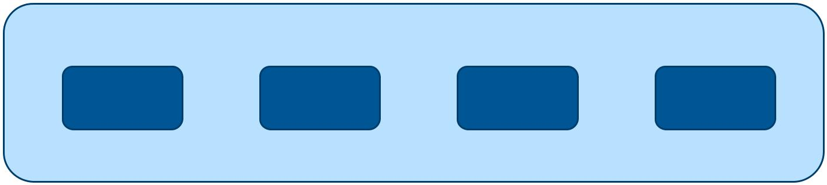

Swarm

encapsulates

hosts

A swarm looks like a single host from

the point of view of allocation but

actually consists of multiple hosts

A Hands on Introduction to Docker
May 1–4, 2017 33

©2017 Len Bass

SATURN 2017

Swarm Master


image

Run request is sent

to swarm master

which selects host

Swarm

Swarm Master is a

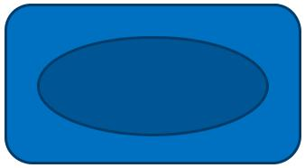

specific container

on a host not in the

swarm

A Hands on Introduction to Docker
May 1–4, 2017 34

©2017 Len Bass

SATURN 2017

How do containers get to hosts?

Three options

- Containers can be copied at each invocation.

  - Copying time is overhead

  - Makes hosts flexible with respect to which containers they run

- Containers can be preloaded on hosts

  - No copying time at invocation

  - When there are multiple different containers, allocator is constrained to allocate to hosts with appropriate containers.

- Some layers can be preloaded on hosts

  - Only copying time for additional layers

  - Allocator is constrained to allocate to appropriate preloaded software

A Hands on Introduction to Docker
May 1–4, 2017 35

©2017 Len Bass

SATURN 2017

Multiple swarms

It is possible to have multiple swarms simultaneously active

Swarm discovery token is used to identify which swarm each host belongs to

A Hands on Introduction to Docker
May 1–4, 2017 36

©2017 Len Bass

SATURN 2017

Scaling Swarms

Having an instance in a swarm be automatically replicated depending on workload is accomplished by utilizing autoscaling facilities of cloud provider

AWS has an EC2 container management facility that combines features of Docker Swarm and autoscaling.

A Hands on Introduction to Docker
May 1–4, 2017 37

©2017 Len Bass

SATURN 2017

AWS EC2 container management
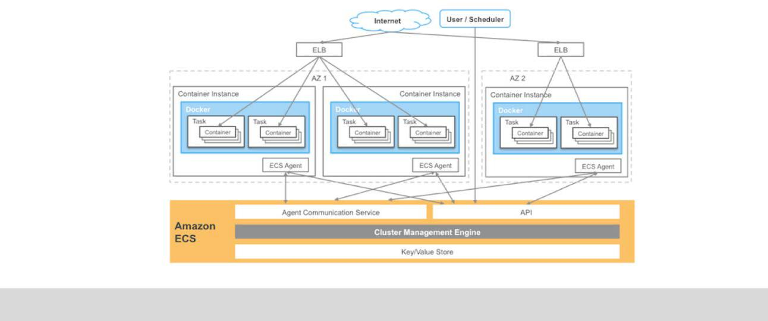

A Hands on Introduction to Docker
May 1–4, 2017 38

©2017 Len Bass

SATURN 2017

AWS Lambda

AWS also has a facility called “Lambda” that consists of preloaded OS + execution engines. Exists for

- Java

- Node.js

- Python

- C#

AWS maintains pool of partially loaded containers that only require app specific layer.

- Load in micro secs.

- Only one request per Lambda instance

A Hands on Introduction to Docker
May 1–4, 2017 39

©2017 Len Bass

SATURN 2017

Summary

A container is a lightweight virtual machine that provides address space, network, file isolation

Docker allows building images in layers and deployment of a new version just requires deploying layers that have changed.

Containers can be managed either on VMs through autoscaling or on preallocated pool for short duration, quick loading

Development workflow is supported through an image repository.

A Hands on Introduction to Docker
May 1–4, 2017 40

©2017 Len Bass

SATURN 2017
Questions and book pitch
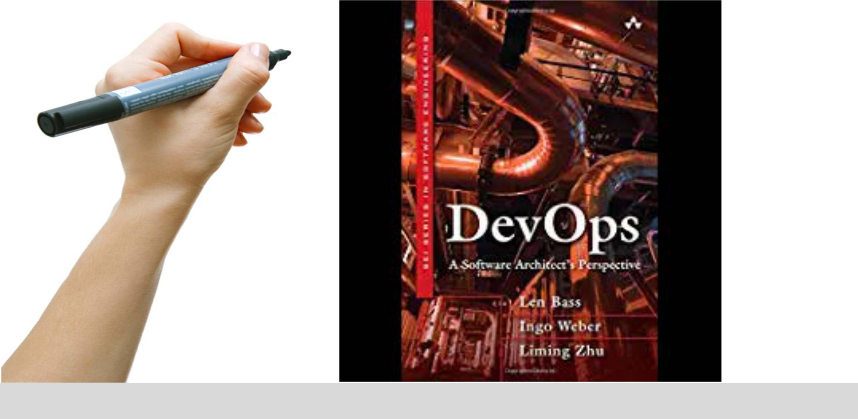

A Hands on Introduction to Docker | 41
May 1–4, 2017 | 41
©2017 Len Bass | 41

